1
2
3
4
5
6
7
Praying Through the 10/40 Window in a Month
Algeria, Africa  Population: 33,333,216  Religions: Islam 97.7%, none 2%, Christianity 0.3%  Persecution Ranking: 27th  Benin, Africa  Population: 8,078,314  Religions: Traditional 47%, Christianity 32%, Islam 20%, other 1%  Persecution Ranking: N/A  Burkina-Faso, Africa  Population: 14,326,203  Religions: Islam 50%, Traditional 31%, Christianity 18%, other 1%  Persecution Ranking: N/A  8 | Chad, Africa  Population: 9,885,661  Religions: Islam 55%, Christianity 28%, Traditional 16%, other 1%  Persecution Ranking: N/A  Djibouti, Africa  Population:496,374  Religions: Islam 94%,  Christianity 5%, other 1%  Persecution Ranking: 29th  9 | Eritrea, Africa  Population: 4,906,585  Religions: Islam 48%,  Christianity 47%, other 5%  Persecution Ranking: 11th  Ethiopia, Africa  Population: 76,511,887  Religions: Christianity 65%, Islam 31%, Traditional 3%, other 1%  Persecution Ranking: 36th  10 | Gambia, Africa  Population: 1,689,359  Religions: Islam 88.6%, Traditional 7%, Christianity 4%, other 0.4%  Persecution Ranking: N/A  Guinea, Africa  Population: 9,947,814  Religions: Islam 85%, Traditional 10%, Christianity 5%  Persecution Ranking: N/A  Guinea-Bissau, Africa  Population: 1,472,780  Religions: Islam 43%, Traditional 41%, Christianity 14%, other 2%  Persecution Ranking: N/A  11 | Libya, Africa  Population: 6,036,914  Religions: Islam 96.5%, Christianity 3%, Buddhism 0.3%, other 0.2%  Persecution Ranking: 20th  Mali, Africa  Population: 11,995,402  Religions: Islam 87%,  Traditional 11%, Christianity 2%  Persecution Ranking: N/A  12 | Mauritania, Africa  Population: 3,270,065  Religions: Islam 99.8%,  Christianity 0.2%  Persecution Ranking: 21st  Morocco, Africa  Population: 33,752,175  Religions: Islam 99.9%,  Christianity 0.1%  Persecution Ranking: 35th  13 | Niger, Africa  Population: 12,894,865  Religions: Islam 97.6%, Traditional 2%, Christianity 0.4%  Persecution Ranking: N/A  Nigeria, Africa  Population: 135,031,164  Religions: Christianity 52.6%, Islam 41%, Traditional 6%,  other 0.4%  Persecution Ranking: 28th  14
Senegal, Africa  Population: 12,521,851  Religions: Islam 92%, Christianity 4.8%, Traditional 3%, other 0.1%  Persecution Ranking: N/A  Somalia, Africa  Population: 9,118,773  Religions: Islam 99.9%,  Christianity 0.1%  Persecution Ranking: 12th  15 | Sudan, Africa  Population: 39,379,358  Religions: Islam 65%, Christianity 23.5%, Traditional 10.6%, other 2.1%  Persecution Ranking: 23rd  Tunisia, Africa  Population: 10,278,158  Religions: Islam 99.7%,  Christianity 0.3%  Persecution Ranking: 40th  Western Sahara, Africa  Population: 382,617  Religions: Islam 100%  Persecution Ranking: N/A  16 | Afghanistan, Asia  Population: 31,889,923  Religions: Islam 97.9 %, Parsee 1.5%, other 0.6%  Persecution Ranking: 7th  Azerbaijan, Asia  Population: 8,120,247  Religions: Islam 84%, none 11%, Christianity 4.6%, other 0.4%  Persecution Ranking: 19th  17 | Bangladesh, Asia  Population: 150,448,339  Religions: Islam 86%, Hinduism 12%, other 1%, Christianity 1%  Persecution Ranking: 41st  Bhutan, Asia  Population: 2,327,849  Religions: Buddhism 72%, Hinduism 23%, Islam 4%, Christianity 0.5%, other 0.5 %  Persecution Ranking: 5th  18 | Cambodia, Asia  Population: 13,995,904  Religions: Buddhism 83%,  other 12%, Chinese 4%,  Christianity 1%  Persecution Ranking: N/A  China, Asia  Population: 1,321,851,888  Religions: none 55.8%,  Chinese 28.5%, Buddhism 8.4%, Christianity 7.3%  Persecution Ranking: 10th  19 | India, Asia  Population: 1,129,866,154  Religions: Hinduism 80%, Islam 13%, Christianity 2%, other 5%  Persecution Ranking: 26th  Indonesia, Asia  Population: 234,693,997  Religions: Islam 80%, Christianity 16%, Hinduism 2%, other 2%  Persecution Ranking: 40th  20 | Japan, Asia  Population: 127,433,494  Religions: Buddhism/Shinto 70%, other 28%, Christianity 2%  Persecution Ranking: N/A  Kazakhstan, Asia  Population: 15,284,929  Religions: Islam 61%,  Christianity 25%, other 14%  Persecution Ranking: N/A  21
Korea (North), Asia  Population: 23,301,725  Religions: None 64%, other 18%, Traditional 16%, Christianity 2%  Persecution Ranking: 1st  Korea (South), Asia  Population: 48,379,392  Religions: None 49%,  Christianity 26%, Buddhist 23%,  other 2%  Persecution Ranking: N/A  22 | Kyrgyzstan, Asia  Population: 5,284,149  Religions: Islam 78%, none 14%, Christianity 7%, other 1%  Persecution Ranking: N/A  Laos, Asia  Population: 6,521,998  Religions: Buddhism 61%, Traditional 31%, Christianity 2%, other 6%  Persecution Ranking: 8th  23 | Malaysia, Asia  Population: 24,821,286  Religions: Islam 58%, Buddhism 22%, other 11%, Christianity 9%  Persecution Ranking: 25th  Mongolia, Asia  Population: 2,951,786  Religions: other 46%, Shamanist 31%, Buddhism 22%,  Christianity 1%  Persecution Ranking: N/A  24 | Myanmar (Burma), Asia  Population: 47,373,958  Religions: Buddhism 83%,  Christianity 9%, Islam 4%, other 4%  Persecution Ranking: 22nd  Nepal, Asia  Population: 28,901,790  Religions: Hinduism 75%, Buddhism 16%, Islam 5%, Christianity 2%,  other 2%  Persecution Ranking: 42nd  Pakistan, Asia  Population: 164,741,924  Religions: Islam 96%, Christianity 2%, Hinduism 2%  Persecution Ranking: 14th  25 | Philippines, Asia  Population: 96,061,680  Religions: Christianity 92%,  Islam 5%, other 2%, none 1%  Persecution Ranking : N/A  Sri Lanka, Asia  Population: 20,926,315  Religions: Buddhism 72%, Hinduism 12%, Islam 8%, Christianity 7%, other 1%  Persecution Ranking: 4th  26 | Tajikistan, Asia  Population: 7,076,598  Religions: Islam 90%, none 9%, Christianity 1%  Persecution Ranking: 32nd  Thailand, Asia  Population: 65,068,149  Religions: Buddhism 92%, Islam 5%, Christianity 2%, other 1%  Persecution Ranking: N/A  27 | Turkmenistan, Asia  Population: 5,097,028  Religions: Islam 92%,  Christianity 3%, other 5%  Persecution Ranking: 13th  Uzbekistan, Asia  Population: 27,780,059  Religions: Islam 84%, none 14%, Christianity 1%, other 1%  Persecution Ranking: 9th  Vietnam, Asia  Population: 85,262,356  Religions: Buddhism 54%,  none 22%, other 16%, Christianity 8%  Persecution Ranking: 16^{h}  28
Bahrain, Middle East  Population: 708,573  Religions: Islam 82%, Christianity 10%, Hinduism 7%, other 1%  Persecution Ranking: 38th  Cyprus, Middle East  Population: 792,604  Religions: Greek Orthodox 78%,  Islam 18%  Persecution Ranking: N/A  29 | Egypt, Middle East  Population: 80,335,036  Religions: Islam 86%,  Christianity 13%, other 1%  Persecution Ranking: 17th  Iran, Middle East  Population: 6,397,521  Religions: Islam 99%,  Bahai 0.5%, Christianity 0.3%,  other 0.2%  Persecution Ranking: 3rd  30 | Iraq, Middle East  Population: 27,499,638  Religions: Islam 97%,  Christianity 2%, other 1%  Persecution Ranking: 18th  Israel, Middle East  Population: 6,426,679  Religions: Judaism 81%, Islam 15%, Christianity 2%, other 2%  Persecution Ranking: N/A  31 | Jordan, Middle East  Population: 6,053,193  Religions: Islam 96%,  Christianity 3%, other 1%  Persecution Ranking: 34th  Kuwait, Middle East  Population: 2,505,559  Religions: Islam 87%, Christianity 8%, Hinduism 3%, other 2%  Persecution Ranking: 31st | Lebanon, Middle East  Population: 3,925,502  Religions: Islam 60%, Christianity 32%, Druze 7%, other 1%  Persecution Ranking: N/A  Oman, Middle East  Population: 3,204,897  Religions: Islam 93%, Hinduism 3%, Christianity 3%, other 1%  Persecution Ranking: 24th | Qatar, Middle East  Population: 907,229  Religions: Islam 79%, Christianity 11%, Hinduism 7%, other 3%  Persecution Ranking: 15th  Saudi Arabia, Middle East  Population: 27,601,038  Religions: Islam 93%, Christianity 5%, other 2%  Persecution Ranking: 2nd  Syria, Middle East  Population: 19,314,747  Religions: Islam 90%, Christianity 5% none 3%, other 2%  Persecution Ranking: 37th | Turkey, Middle East  Population: 71,158,647  Religions: Islam 99.6%, Christianity 0.3%, Judaism 0.1%  Persecution Ranking: 30th  United Arab Emirates, Middle East  Population: 4,444,011  Religions: Islam 66%, Hinduism 17%, Christianity 9%, other 8%  Persecution Ranking: 33rd
Yemen, Middle East  Population: 22,230,531  Religions: Islam 99.9%,  Christianity 0.1%  Persecution Ranking: 6th  Albania, Europe  Population: 3,600,523  Religions: Christianity 42%,  Islam 39%, other 19%  Persecution Ranking: N/A | Gibraltar, Europe  Population: 28,002  Religions: Christianity 88%, Islam 4%, Judaism 2%, Hinduism 2%, none 3%, other 1%  Persecution Ranking: N/A  Greece, Europe  Population: 10,722,816  Religions: Greek Orthodox 98%, Islam 1%, other 1%  Persecution Ranking: N/A | Malta, Europe  Population: 403,532  Religions: Christianity 98%,  other 2%  Persecution Ranking: N/A  Portugal, Europe  Population: 10,676,910  Religions: Christianity 87%,  none 12%, other 1%  Persecution Ranking: N/A  Spain, Europe  Population: 40,491,052  Religions: Christianity 94%,  other 6%  Persecution Ranking: N/A | CIA Factbook 2008  Open Door World Watch List 2008  Window International Network, PO Box 49127, Colorado Springs, CO 80949 USA www.win1040.com

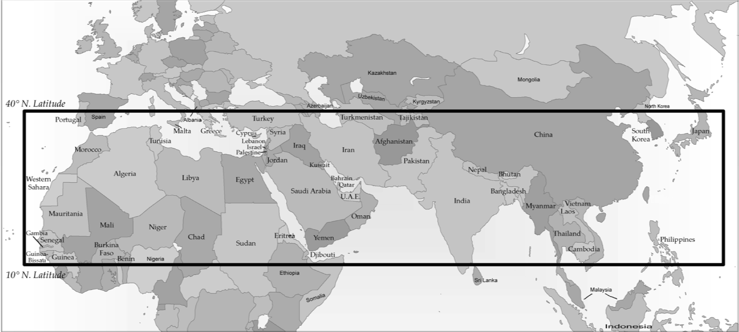
10/40 Window Region
Data Source: Patrick Johnstone, Operation World, 2001
Map 10/40 Window by Global Mapping International—www.gmi.org

